**An Empiricist’s Guide to Modern Coexistence Theory for Competitive Communities**

Key-words: competition experiments, modern coexistence theory, niche differences, relative fitness differences

**Abstract**

While most ecological theories have historically invoked niche differences as the primary mechanism allowing species coexistence, we now know that coexistence in competitive communities depends on the balance of two opposing forces: niche differences (ND) that determine how species limit their own growth rate versus that of their competitor, and relative fitness differences (RFD) that establish competitive hierarchies among species. Several different empirical methods have been proposed for quantifying ND and RFD in order to make predictions about coexistence of species, yet it remains unclear which method(s) are appropriate for a given empirical study and whether or not those methods yield the same information. Here we compare six different empirical methods and provide a practical guide to help empiricists determine which method(s) are best for their study system. We show that there are important tradeoffs between mechanistic methods, which require detailed understanding of species’ resource use and physiology but are more tractable experimentally, and phenomenological methods which do not require this detailed information but can be impractical for some study designs. Finally, we show that the methods do not always yield the same values and therefore we caution against future syntheses that compile these estimates from different empirical studies.

**Introduction**

Throughout most of the history of community ecology, it has been assumed that niche differentiation among species is the primary biological mechanism that can offset the negative impacts of interspecific competition on species coexistence (Gause 1934, Tilman 1982, Leibold 1995, Chase and Leibold 2003). This idea originated when Volterra (1931) introduced a dynamic model of competition that became the foundation for the competitive exclusion principle, which states that if two species have identical niche requirements then one of them will inevitably become locally extinct (Gause 1934). The competitive exclusion principle led to two conclusions about competitive communities: 1) species will coexist only if they are limited by different resources or consumers at the same location and time, or if they partition resources or consumers in space or time and, as a result, 2) ecosystems should contain only as many species as there are limiting resources or consumers (Hutchinson 1959, Levin 1970).

Most empirical work that followed the competitive exclusion principle focused on identifying or quantifying the impact of niche differences on biodiversity. But even as this empirical work was proceeding, some theoreticians began to show that coexistence depends on more than just niche differences among species. Indeed, subsequent modeling efforts showed that even in the absence of niche differentiation, species may coexist (or exhibit delayed competitive exclusion over long periods) as a result of similarities in demographic parameters such as equilibrium population sizes (MacArthur and Levins 1967, Roughgarden 1976, Slatkin 1980) or growth rates (Vandermeer 1975). At the very least, these theoretical advances seemed to suggest that niche differences were not solely responsible for species coexistence.

Starting around 2000, theories of species coexistence began to undergo fairly a major revision. In 2001, Hubbell hypothesized that niche differences are not required for coexistence at all (Hubbell 2001). Instead, he argued that species coexist because their demographic parameters are identical, or nearly so, such that the consequences of their interactions are essentially equal among all species. Based on this neutral theory, Hubbell argued that the biodiversity observed in nature can be explained by a series of stochastic events that cause some populations to become dominant while others become extinct.

Even as Hubbell was developing his neutral theory, Chesson (2000) was completing his own synthesis of coexistence theory – one that would ultimately provide a framework for integrating the niche and neutral perspectives on biodiversity. Chesson’s coexistence framework was built on his insight into the invasibility criterion: a pair of species will only coexist for long time periods if each species is capable of invading a steady-state population of its competitor. Chesson showed how a species’ growth rate when invading a resident species can be decomposed into two general terms, which he called stabilizing and equalizing forces. Stabilizing forces cause species to limit their own growth rate more than they limit the growth rate of other species (intra > interspecific competition). These stabilizing forces, also known as niche differences (ND, equal to 1- niche overlap, 𝜌), occur when species partition limiting resources in space or time, or when they experience differential consumption by consumers. In contrast, equalizing forces minimize differences in competitive abilities among species. Equalizing forces – which were originally termed average fitness differences (Chesson 2000), but have more recently been called relative fitness differences (RFD, Carroll et al. 2011, HilleRisLambers et al. 2012, Adler et al. 2013) – are the result of variation in species-specific biological traits such as potential growth rates, carrying capacities, or resistance to consumers. While prior theoretical work had noted how these biological parameters can slow rates of competitive exclusion (Roughgarden 1976, Vandermeer 1975), the novelty of Chesson’s work was to show that coexistence in most models of competition are ultimately controlled by the balance of two forces (ND and RFD) that ultimately determine whether species maintain non-negative long-term growth rates in competitive communities (Chesson 2000).

It has subsequently been shown that Hubbell's neutral theory represents a specific, limiting case of Chesson's coexistence theory where NDs and RFDs are both zero, causing the outcome of competition to be approximated by a random walk toward extinction (Adler et al. 2007). Stabilizing and equalizing forces have been identified in both fluctuation-dependent mechanisms (e.g. storage effects) and fluctuation-independent mechanisms of coexistence (e.g. competition for a limiting resource) (Miller and Klausmeier 2017, Barabás et al. 2018, Ellner et al. 2019). Thus, Chesson’s work is not a new model of species interaction, but rather a general, but not the only (see e.g. Barabás et al. 2018 and Letten et al. 2017), framework for predicting species coexistence across many different types of models of competition. The value of this framework for empiricists (and also theoreticians) is that it distills divergent models, each with their own multitude of equations and parameters, down to two terms that have clear ecological interpretations (Chesson 2012; Barabás et al. 2018). For example, predicting coexistence of two species of animals consuming several species of plants can be accomplished via numerical simulation or analytical solution using the well-known MacArthur consumer-resource model. However, this approach arguably gives less insight to the ecological mechanisms influencing coexistence than if those same parameters were used to calculate a niche overlap and fitness difference (Chesson 1990; Carroll et al. 2011).

Since the original development of Chesson’s ideas about coexistence, additional theoretical work has focused on expanding Chesson’s theory beyond pairwise to multi-species interactions, beyond competition to consider other interactions like facilitation (Carroll et al. 2011), and towards more mechanistic interpretation of the stabilizing and equalizing forces that define and relative fitness differences (ND and RFD, Barabás et al. 2018). In addition to a fast-moving body of theoretical work, a growing amount of attention in ecology has turned towards the empirical estimation of ND and RFD in order to determine how these forces contribute to coexistence in real communities (Adler et al. 2018, Lanuza et al. 2018, Ocampo-Ariza et al. 2018, Armitage and Jones 2019, Dostál et al. 2019, Grainger et al. 2019, Hart et al. 2019, Li et al. 2019, Matías et al. 2019, Wainwright et al. 2019, Zepeda and Martorell 2019). Empiricists have now proposed a number of different experimental and observational approaches to quantify ND and RFD among pairs of competing species. The various methods for quantifying ND and RFD have been derived from different models of species interactions, make different assumptions about how those interactions operate, and use different study designs to obtain information. Therefore, it remains unclear which method(s) are best suited for a given study, whether the methods give comparable estimates of ND and RFD, and whether the methods actually make the same prediction regarding coexistence. If Chesson’s theory is to become widely implemented in empirical studies and in applied contexts, we need a ‘users guide’ to help ecologists decide among these empirical approaches and identify potential shortcomings and pitfalls for each method.

The goal of our paper is to analyze and compare existing empirical approaches for predicting pairwise coexistence among species in competitive communities. Here we provide a summary and comparison of five methods that have been proposed to measure ND and RFD empirically, and a sixth method that does not give estimates of ND and RFD but has been used to predict coexistence based on Chesson’s theory. In Part 1, we explain the theoretical basis of each method, illustrate how it can be implemented empirically, and ask whether the methods yield the same estimates of ND and RFD. In Part 2 we provide a list of decision steps to guide empiricists in selecting the most appropriate method(s) for their study system and aims. In Part 3, we discuss the main advantages and disadvantages of the methods and make suggestions for future empirical work on coexistence theory.

**Part 1. Summary of Empirical Methods for Implementing Chesson’s Theory**

In this part of the paper we briefly summarize Chesson’s theory, then summarize each of five empirical methods for measuring ND and RFD by explaining how the methods relate to Chesson’s theory, how they can be implemented empirically, and highlight critical limitations and assumptions.

*1.1. Brief review of Chesson’s theory*

When Chesson first introduced his theory for coexistence, he did not prescribe a specific empirical approach or experiment that should be used to estimate ND and RFD in real biological communities. Instead, he used a phenomenological model of competition to show how the mutual invasibility criterion, a prerequisite for coexistence, depends on how each species limits their own growth rate versus that of their competitor (Chesson 1990). For a pair of species to coexist, niche difference (or 1-𝜌, niche overlap) must be sufficiently large to offset and stabilize the competitive hierarchies generated by fitness differences. Specifically, Chesson’s criterion for mutual invasibility can be expressed as an inequality involving both niche overlap (𝜌) and fitness differences (𝜅1 / 𝜅2) (Equation 1).

(1)

or following notation of Carroll et al. (2011) and Narwani et al. (2013),

In this inequality, the term 1-ND represents the degree of niche overlap (*ρ* in Chesson 1990, 2018), which ranges from zero when species do not share any resources to one when the resource requirements of species are identical. RFD represents the ratio of competition-free fitness among the two species (𝜅1 / 𝜅2 in Chesson 1990). Several other terms have been used to describe differences in fitness including fitness ratio (Chesson 2012), fitness inequality (Adler et al. 2007), average fitness differences (Chesson 2003, Chesson 2018), or competitive advantage (Barabás et al. 2018). However, for simplicity and consistency with at least some previous studies, we choose to describe these terms as niche differences and relative fitness differences. When two species exhibit identical niches (ND equals 0), their RFD alone determines the competitive hierarchy and which species will become extinct. If this inequality is not satisfied, then one of the species is unable to maintain long-term, positive growth rates and will go locally extinct.

Chesson showed how ND and RFD can be derived from the classic Lotka-Volterra competition model (Chesson 2000). In this model, the *per capita* growth rate of species *i* is a function of both intraspecific and interspecific competition as described by Equation 2:

(2)

In Equation 2, *Ni* is the density of species *i,* and *ri* is the intrinsic per capita growth rate of species *i*. The intra-specific competition coefficient *αii* describes the reduction in the *per capita* relative growth rate of species *i* for each additional individual of species *i,* and is equal to the inverse of the carrying capacity (*Ki*) for species *i*. The inter-specific competition coefficient *αij* describes the reduction in the *per capita* relative growth rate of species *i* for each additional individual of species *j*. Equations 3 and 4 relate the inter- and intra-specific interaction coefficients from the Lotka-Volterra model to RFD (Carroll et al. 2011, Chesson 2018):

(3)

(4)

ND and RFD estimates from Equations (3) and (4) can then be used in Equation 1 to predict coexistence. The focus of this review is to provide empiricists with a practical guide to selecting and implementing empirical methods for modern coexistence theory. Other recent papers provide a more detailed exploration of the mechanics of modern coexistence theory and its extension to other aspects of ecology (Barabás et al. 2018, Chesson 2018, Hart et al. 2018, Broekman et al. 2019, Ellner et al. 2019).

Because Chesson derived ND, RFD and the inequality for mutual invasibility based on the Lotka-Volterra competition model, we use the same approach to explain five different empirical approaches for estimating ND and RFD.

*1.2 Method based on the Lotka-Volterra model for continuous reproduction*

Since Chesson originally used the Lotka-Volterra model to explain his criterion for coexistence (Section 1.1), the most direct empirical approach for estimating ND and RFD is to parameterize the Lotka-Volterra competition model for continuous reproduction (Equation 2) using data collected from experiments or time-series observations from natural ecosystems.

1.2.1 Empirical approaches. While numerous studies have parameterized the Lotka-Volterra model for continuous reproduction, relatively few empirical studies have parameterized the model in order to calculate ND and RFD (Armitage and Jones 2019). Empiricists have two options for estimating the per capita intraspecific (*αii* and *αjj*) and interspecific competition coefficients (*αij* and *αji*) needed to calculate ND and RFD using Equations 3 and 4. The first option is to measure the population density of each species over time, using plots or microcosms containing each species grown as a monoculture and, separately, one co-culture of the two species (Figure 1). From these time series, the empiricist would fit Equation 2 for each pair of species using maximum likelihood, Bayesian, or least-squares methods (Pascual and Kareiva 1996, Geijzendorffer et al. 2011, Armitage and Jones 2019) and obtain the four interaction terms used in Equations 3 and 4.

An alternative option is to avoid fitting the Lotka Volterra model directly to the timeseries and, instead, use simplifications to derive inter- and intraspecific interaction coefficients from the carrying capacities and short-term growth rates observed in experiments (Figure 1). From each monoculture timeseries, the empiricist could estimate the maximum per capita growth rate of each species (*ri*), which occurs as the species’ density approaches zero, and the steady-state population size of each species in monoculture (carrying capacity, *Ki*). The intraspecific interaction coefficients could be estimated as the slope of each species’ per capita growth rate as a function of its own population density (Figure 1, right), although this relationship can be non-linear in practice (see Limitations, below). Alternatively, an empiricist can assume that intraspecific interaction coefficients are equal to the inverse of the carrying capacity for each species in monoculture (*αii=*1/*Ki*). Next, the empiricist can substitute parameter estimates from the monocultures and use linear regression to estimate the interspecific interaction coefficients (*αij* and *αji* ) in Equation 2 from growth rates observed near equilibrium. We illustrate these steps in the Supplemental Computer Code. Finally, the empiricist can use all four interaction coefficients to compute ND and RFD using Equations 3 and 4.

1.2.2 Limitations. A critical assumption of this approach is that the intra- and inter-specific competition coefficients of the Lotka Volterra model are fixed with respect to population sizes of either species. In other words, the first individual and the last individual added to a population are assumed to have the same per capita effect on the growth rates of its own species or that of its competitor. This assumption is not always met in real biological communities where intra- and inter-specific competition coefficients can depend on species’ densities (Smith-Gill and Gill 1978, Abrams 1980, Chesson 2018). Appendix A in the Supplementary Material shows that, when applied to numerical simulations based on a well-known consumer resource model, intraspecific coefficients measured in monoculture near equilibrium lead to inaccurate predictions regarding coexistence. However, when the intraspecific interaction terms are replaced by 1*/Ki* the method yields accurate predictions. Therefore, in those situations where competition coefficients are fixed with respect to population size, or can be measured at low population densities of each species, this approach can be used to estimate ND and RFD. Another limitation of this approach, and many of the other methods, is that it only applies to competitive interactions and thus Equations 3 and 4 are not compatible with facilitation. For systems where facilitation is expected to be important, empiricists can consider alternative approaches listed in Section 3.3.

*1.3 Annual plant model for discrete reproduction*

Although the Lotka-Volterra method for continuous reproduction is seldom used to estimate ND and RFD, there is extensive empirical work using similar models where reproduction occurs at discrete intervals. The annual plant model for discrete reproduction (Adler et al. 2007, Chesson 2008) is used most frequently to estimate ND and RFD (Levine and HilleRisLambers 2009, Godoy and Levine 2014, Godoy et al. 2017, Lanuza et al. 2018, Bimler et al. 2018, Matías et al. 2018, Broekman et al. 2019), but the closely related Ricker (Hart and Marshall 2013, Chu and Adler 2015) and Beverton-Holt (Cushing et al. 2004, Fujiwara et al. 2011, Germain et al. 2016, Hart et al. 2018) models could also be employed using a similar approach.

1.3.1 Empirical approaches. Unlike the Lotka-Volterra model for continuous reproduction, which requires long timeseries for parameterization, the methods for discrete growth can be parameterized based on a single generation. To do this, an empiricist would grow each focal species at multiple different population densities of its own species and that of its competitor (Godoy and Levine 2014). At the end of the growing season, the number of seeds produced by each individual plant in the absence of competition is used to calculate the fecundity term (λ) used in Equation 5:

(5)

In this model, *Ni,t* is the density of species *i* at time *t* and the interaction coefficients (*α*) are equivalent to those in the Lotka-Volterra model but describe effects of competition on fecundity instead of growth rate. Using the density and fecundity of each focal species and its competitor, an empiricist can use maximum likelihood, least squares, or Bayesian methods to fit the interaction coefficients needed to calculate ND following Equation 2 and RFD following Equation 6 (Godoy and Levine 2014, Bimler et al. 2018, Lanuza et al. 2018, Matías et al. 2018):

(6)

In Equation 6,

Levine and HilleRisLambers (2009) demonstrated how the annual plant model can be implemented experimentally to estimate niche differences. In their study with 10 species of grassland plants, they manipulated the density of each focal species by varying the number of seeds belonging to the focal species versus all other species. At the end of the growing season, they quantified ND as described above. Then, using their estimates of ND from this method, they experimentally removed the impact of those ND to illustrate that ND was partially responsible for coexistence.

1.3.2 Limitations. An obvious limitation of the annual plant model is that it can only be applied to species and communities that follow discrete reproduction. This makes the method attractive for studying plant communities, but it could be impractical for other communities which are better suited to the Lotka-Volterra method for continuous reproduction or one of the other methods summarized here. Also, similar to the Lotka-Volterra model for continuous reproduction, this method assumes that the inter- and intraspecific interaction coefficients are independent of species’ densities. To verify that this assumption is met, an empiricist would need to grow each species and combination at several different densities in their experiment to check for approximate linearity. Another limitation of the annual plant model, and also the Lotka-Volterra model for continuous reproduction, is when species engage in direct facilitation (Rohr et al. 2014). Specifically, facilitation can make one or more interaction coefficients negative, which is problematic for the calculation of ND and RFD following Equations 3 and 4. The problem caused by facilitation is not specific to the method based on the Lotka-Volterra model and is discussed further in Section 3.3.

*1.4 Sensitivity method*

The third method for estimating ND and RFD, the sensitivity method, is similar to the Lotka-Volterra method in that it requires information from direct competition experiments. The sensitivity method quantifies the proportional reduction in a species’ growth rate when invading a steady-state population of its competitor (Carroll et al. 2011, Narwani et al. 2013). In this method, the maximum growth rate of each species in monoculture (*µi*) and when invading a steady-state population of the competitor species (*µij*) are used to calculate each species’ sensitivity to interspecific competition (*Si*) using Equation 7:

(7)

Carrol et al. (2011) and Narwani et al. (2013) have shown that ND is proportional to the geometric mean of these sensitivity measures, whereas RFD represent variation around the mean:

(8)

(9)

A species’ sensitivity to competition is jointly determined by ND and RFD (Carroll et al. 2011, Narwani et al. 2013). Specifically, greater ND between the two species reduces the impact of interspecific competition so that *Si* will approach zero. Greater RFD, on the other hand, causes species to be asymmetrically affected by competition such that one species’ sensitivity increases while the other’s decreases. While Carroll et al. (2011) showed that the sensitivity metrics can be used to recover ND and RFD from MacArthur’s consumer resource model, and Narwani showed how the sensitivity method gives ND and RFD compatible with Chesson’s theory, in Supplementary Materials Appendix B we show explicitly how Equations 8 and 9 from the sensitivity method are equivalent to Equations 3 and 4 under the specific limiting assumption that the resident species is at steady state and the invader is rare.

1.4.1 Empirical approaches.The experiment by Narwani et al. (2013) provides an example for how to implement the sensitivity method empirically (Gallego et al. 2019, Grainger et al. 2019, Li et al. 2019). Their experimental system involved species of freshwater green algae growing under controlled conditions in the laboratory. They grew each species as a monoculture, starting from low densities and allowing the populations to reach their carrying capacity. From these time series, they quantified the per capita maximum growth rate of each species as a monoculture (*µi* and *µj*), which occurs when the focal species is at low density. After each species reached its carrying capacity, they introduced the other species from low density (e.g. 0.01% of *K*) and quantified the per capita growth rate of each species when invading the other (*µij* and *µji*). Finally, for each pair of species, they used these growth rates to calculate the sensitivity metrics (*Si* and *Sj*) using Equation 7 and used those sensitivity metrics to calculate ND and RFD using Equations 8 and 9.

1.4.2 Limitations.Despite its simple design and straightforward parameterization, the sensitivity method has several limitations. First, the method is only practical for organisms that can be grown as monocultures and whose population growth rates can be measured over tractable periods of time. Second, this method requires that the resident species is maintained at a steady-state population density, which could be difficult to achieve outside a chemostat system. Third, it is important to note that the invasion growth rates (*µij* and *µji*) must be measured when the invader population density is low. If the growth rate of the invader species were measured at greater density of the invader species or lower density of the resident species (i.e. long after invasion), then the would be affected by both intra- and inter specific competition and the resulting prediction regarding coexistence could be incorrect. Finally, the sensitivity method can only be applied to competitive interactions (Narwani et al. 2013). When species engage in facilitation, invasion growth rates could be higher than when grown in monoculture (*Si*<0), making Equations 8 and 9 inappropriate.

*1.5 Parameterizing MacArthur’s consumer resource model*

The fourth method to estimate ND and RFD from empirical data is to parameterize MacArthur’s consumer-resource model (MacArthur 1970) then use these parameters to calculate ND and RFD (Chesson 1990, Chesson 2000, Carroll et al. 2011). This method is different from the Lotka-Volterra, annual plant model, and sensitivity methods because it does not rely on experiments where the species are grown together in order to quantify how the species influence each other’s growth rates. Instead, this method works by parameterizing a mechanistic model that describes how species consume, and thus compete for, two or more prey resources (MacArthur 1970), then reorganizing those parameters following an analytical solution to estimate ND and RFD for assessing Chesson’s inequality. In this model, species are assumed to interact only through their resources (i.e. no intraguild predation or facilitation).

MacArthur’s CRM is composed of differential equations representing the growth of each consumer species as a function of resource densities (Equation 10) and a differential equation (or set) that describes the population dynamics of each prey resource and their mortality due to consumption by the consumers (Equation 11).

(10)

(11)

In this model *Xi* is population density of the consumer species *i* and *Rl* is population density of the prey resource *l*. The term *bi* represents the effect of prey consumption on the growth rate of the consumer, *rl* is the maximum per-capita growth rate of prey resource *l*, *Kl* is the carrying capacity for the prey species *l*, *wil* represents the increase in consumer population density for each unit of prey resource *l* consumed. The term c*il* is the resource capture rate by consumer *i* on resource *l* and *mi* is the density-independent mortality for consumer species *i*. By implementing a time-scale separation technique (Chesson 1990), parameters in MacArthur’s consumer resource model can be used to calculate ND and RFD using Equations 12 and 13 (Carroll et al. 2011):

(12)

(13)

The estimates of ND and RFD from this method can then be used to evaluate Chesson’s inequality and predict coexistence.

1.5.1 Empirical approaches.Because we are not aware of any empirical studies that have parameterized the MacArthur model for the purpose of estimating ND and RFD, we describe the experimental approach that would be required (Figure 3). First, the empiricist would identify or define the prey resources that are available to the consumer species. Each prey resource would be inoculated or planted at low density into an environment free of other prey resources and consumers (see Lotka Volterra model for continuous reproduction), then the population density would be measured over time in order to estimate the per capita maximum growth rate of the prey (*rl*, which occurs as the prey population density approaches zero) and its carrying capacity (*Kl*, which occurs when the prey growth rate approaches zero). Next, the experimentalist would introduce each consumer species into several different densities of each prey resource growing as a monoculture. Under those different prey resource densities, the experimentalist would measure the per capita consumption rate of prey resource by the consumer species (*cil*, by linear regression of consumption versus prey density) and the yield of consumer density or biomass per unit prey resource consumed (*wil*). These parameters can then be used in Equations 12 and 13 to obtain ND and RFD, which can subsequently be used directly in Equation 1 to predict coexistence.

1.5.2 Limitations.The method based on MacArthur’s model requires as many consumption experiments as there are resources, and each of these experiments involves measuring consumption rates at a range of resource species densities (Figure 3 b and c). The precise number of parameters to be estimated depends on the number of prey resources considered by the model. For example, for two consumer species and three prey resources (Figure 3), the hypothetical experiment requires 18 parameters to be quantified: 3 different maximum per capita growth rates and 3 carrying capacities of the prey resources (*rl* and *Kl*, *l*= 1 to 3), 6 per capita consumption rates (*cil*; *i*= 1 and 2, *l*= 1 to 3), and 6 yields (*wil*; *i*=1 and 2, *l*=1 to 3). While this constraint does not impact the ability of the method to predict coexistence under defined conditions, it could limit the extent to which those predictions can be applied to natural environments where the number of potential prey species is large.

*1.6 Parameterizing Tilman’s consumer resource model*

Like the method based on MacArthur’s CRM, the method based on Tilman’s CRM does not require species to be grown together in a competition experiment. However, unlike the method based on MacArthur’s CRM, the method based on Tilman’s CRM is specific to abiotic resources that are controlled by a constant rate of supply and do not have their own intrinsic growth rate (i.e. a chemostat). While Tilman’s R* model was extended to include biotic resources (Tilman 1982), there is not presently an analytical translation of that model to obtain ND and RFD. Letten and others (2017) showed how Tilman’s consumer resource model (Tilman 1977) can be reorganized to a Lotka-Volterra form in order to estimate ND and RFD. In this model, one set of differential equations describes the growth of each consumer species as a function of the availability of two essential resources (Equation 14) and another set of equations describes the dynamics of abiotic resources and their depletion due to uptake by the consumer and dilution (Equations 15 and 16).

(14)

(15)

(16)

In this model, *N­i* is the population density of species *i*, *ri* is the maximum per capita growth rate of species *i*, *yii* is the yield of species *i* on resource *i*, and *kii* is the half saturation constant for growth of species *i* on resource *i*. The term *Si0* is the external supply concentration for resource *i*, *Si* is the concentration of resource *i* in the environment, and *D* is equal to both the supply rate of resources and the density-independent loss rate for both species.

To use this method to calculate ND and RFD an empiricist must first determine which species is limited by each resource by comparing the supply ratio for the two resources against the R*s for each species at the pre-determined dilution rate. (e.g., using resource-ratio theory (Tilman 1982)). Under conditions where species 1 is limited by resource 2 and species 2 is limited by resource 1, Equations 17 and 18 can be used to estimate ND and RFD:

(17)

(18)

Equations 17 and 18 are simplifications for this combination of limiting resources (Supplementary Material Appendix D). The appendix by sforms of the equations for other possible resource limitation scenarios, provided that each species is able to persist as a monoculture.

1.6.1 Empirical approaches.To illustrate how this method could be implemented empirically, we describe the approach that Tilman first used to parameterize his model (Tilman 1977). First, he inoculated each species as a monoculture into growth medium containing a range of concentrations of the limiting resource (either silicate or phosphate) with all other resources in excess. By calculating the exponential growth rate at each level of the limiting resource he fitted estimates of half saturation constants (*kij*) for each resource and a single maximum per capita growth rate for both resources (*ri*) (Figure 4). Next, Tilman quantified the yields (*yij*) of each species on each resource by measuring the elemental content of a known number of cells. As shown by Letten et al. (2017), the parameters described above can be used to predict coexistence under different resource supply ratios and dilution rates in a chemostat.

1.6.2 Limitations.The method using Tilman’s CRM requires an empiricist to know precisely which resources the species compete for, which limits its applicability to many real scenarios and ecosystems where the identity of limiting resources and the supply rates may not be known. Additionally, the resource supply concentrations must be fixed and the supply rates must be equal to the density-independent loss rate, which can only be achieved in certain experimental settings like chemostats.

*1.7 Negative frequency dependence (NFD) method*

The final method that we summarize, the negative frequency dependence method (NFD), has not been proposed as a means of obtaining estimates of ND and RFD that are directly compatible with Chesson’s inequality (Equation 1). In fact, in Supplementary Material Appendix C, we explicitly show that the NFD method cannot be used to derive estimates of ND and RFD that are consistent with Chesson’s theory. However, the NFD method can be used to predict coexistence using the criterion of mutual invasibility and has been used to illustrate the impacts of ND and RFD in manipulative experiments (Adler et al. 2007, Levine and HilleRisLambers 2009, Schreiber et al. 2019).

The NFD method quantifies the change in per capita growth rate of a species as a function of its frequency in a community (Adler et al. 2007, Levine and HilleRisLambers 2009). Here the frequency of a species refers to the proportion of total biomass or individuals in a community belonging to that species. This method makes the key assumption that the community is saturated with respect to total species densities. Thus, a frequency of 1 represents a steady-state monoculture at its carrying capacity and any increase in the population density of one species will be offset by a decrease in population density of another species. Under this assumption, increasing species *i*’s frequency means that individuals of species *i* will compete more with individuals of its own kind than with individuals of other species, and will thus experience stronger intraspecific competition than interspecific competition. Therefore, if intra-specific competition is greater than inter-specific competition, the species affects its own growth rate more than it affects the growth rate of other species, and the NFD slope should be negative. As discussed below, this relationship is not always linear and its slope can be positive under some conditions (Levine and HilleRisLambers 2009, Godoy and Levine 2014).

The NFD method is most often used as a graphical approach for understanding the impact of ND (Figure 5). Adler et al. (2007) argue that a more negative NFD slope represents a stronger stabilizing force, which is proportional to the ND in Chesson’s inequality. Similarly, they argue that the difference between species’ growth rate in the absence of stabilizing forces is the equalizing force, proportional to RFD. Although they did not use the NFD method to estimate ND and RFD, Adler and others showed how both the slope and elevation of the NFD plot are needed to accurately predict whether each species has a positive growth rate at a frequency approaching 0. If this condition is met, the species are mutually invasible and should coexist based on Chesson’s criterion. However, this is not the exclusive condition for coexistence. Recent work has shown that if species exhibit non-linear frequency dependence -positive slopes at some frequencies and negative slopes at other frequencies - they can potentially coexist at intermediate frequencies (Schreiber et al. 2019). This example from NFD method illustrates how non-linear density dependence (e.g. Allee effects) complicate the invasibility criterion but can be compatible with long-term coexistence among pairs and communities (Barabás et al. 2018). In the next section we discuss how deviations from linearity and/or positive frequency dependence impact empirical application of this approach.

1.7.1 Empirical approaches.The NFD method could be implemented using either experiments or observations from natural ecosystems (Figure 5a). Using the experimental approach, an empiricist would need to ensure that total community density or biomass was saturated such that any decrease in the resident’s population density is replaced with the invader. Next, the empiricist could use the time series for each species’ density to calculate the per capita growth rate and frequency of each species at each time point. Alternatively, the NFD method could be implemented using observational data from different habitat patches or along ecological gradients in natural ecosystems (Adler et al. 2010). This approach could allow an empiricist to estimate frequency dependence for species that are not easily manipulated (e.g. trees). ­­Using pairs of growth rate and frequency from either experiments or observational studies, the empiricist can determine whether both species exhibit a positive growth rate when their frequencies approach zero (demonstrating mutual invasibility) or at some intermediate frequency of the two species (demonstrating a locally stable equilibrium).

Numerous studies have used the NFD approach to illustrate the effects of ND and RFD in both models and real biological communities (Levine and HilleRisLambers 2009, Yenni et al. 2012, Godoy and Levine 2014, Yenni et al. 2017, Armitage and Jones 2019). For example, Levine and HilleRisLambers (2009) removed the effect of niche differences on growth rates by maintaining each species’ density at a constant, non-equilibrium level that was not subject to competition from other species. They then quantified the slope of NFD by regressing the growth rate of each species against its frequency in the initial community. Their experiment showed that removing niche differences among species (even without measuring them) led to dominance by the species with the highest per capita growth rates. In other words, in the absence of ND the outcome of competition was determined by RFD.

1.7.2 Limitations.Despite some of the desirable aspects of the NFD method in terms of empirical approaches (above), it has three key caveats. First, the NFD method does not yield estimates of ND and RFD that are consistent with the other methods. This may not be a concern if the purpose of the study is simply to predict species coexistence or demonstrate the impact of ND and RFD. Moreover, the NFD approach could potentially be used to estimate community-wide average invasion growth rates and thus community stabilization (Barabás et al. 2018). Second, the NFD method assumes that the community density is saturated across the range of species’ frequencies observed, but it may not be possible to verify this condition in observational studies based on natural ecosystems. If this assumption were not met, both species could exhibit positive growth rates across all frequencies, which would lead to inaccurate predictions for long-term coexistence.

The third caveat of the NFD method is that the relationship between a species’ frequency and growth rate can be nonlinear (Figure 5). As long as the relationship between a species’ frequency and its growth rate is linear, the NFD slope and elevation can theoretically be used to predict whether both species will have positive growth rates when rare, thus meeting the mutual invasibility criterion. In Appendix C, we show the NFD method using linear extrapolation can lead to incorrect predictions about species coexistence when applied to systems with nonlinear relationships between species’ growth rates and densities. If the relationship between each species’ frequency and its growth rate is nonlinear or locally positive (Schreiber et al. 2019), then an empiricist would need to either 1) measure the growth rate of each species across the full range of frequencies to establish that the growth rate of each species is linearly related to its frequency or 2) evaluate the growth rate of each species when rare (i.e. directly demonstrate mutual invasibility).

*1.8 Do the methods give the same prediction regarding coexistence?*

Although each of the six methods can be used to predict coexistence, the experimental approaches required for those methods are different, and it is not clear that the methods would yield the same predictions (or values of ND and RFD) if applied to the same study system. Here we use numerical simulations to investigate whether four of those methods, when implemented as shown in Figures 1, 2, 3, and 5, lead to the same prediction regarding coexistence and give the same estimates of ND and RFD. We could not include both the method based on MacArthur’s CRM and the method based on Tilman’s CRM since these mechanistic models have incompatible assumptions – the resources in MacArthur’s CRM have their own population dynamics while the resources in Tilman’s CRM are abiotic and governed by a constant rate of supply. Similarly, we could not apply methods based on discrete versus continuous reproduction to the same simulations. We chose to use numerical simulation for this demonstration since we are unaware of any empirical dataset that has been, or could be, analyzed using more than two of the methods. The numerical simulations were based on Tilman’s consumer-resource model (Tilman 1977) with two species of phytoplankton competing for two essential resources (See Supplementary Material Appendix A). For each set of resource conditions, we performed numerical simulations that represent four distinct methods: 1) fitting the Lotka-Volterra model for continuous reproduction (Figure 1), 2) the sensitivity method (Figure 2), 3) the method using Tilman’s CRM (Figure 4), and 4) the NFD method (Figure 5).

Under specific limiting assumptions described above, all four methods made the same prediction about coexistence and these predictions matched the outcome based on the simulations (Supplementary Material Appendix A Figure A2). However, this agreement among the methods was conditional on how the Lotka-Volterra and NFD methods were implemented. The Lotka-Volterra method only matched the predictions for coexistence from the other methods when we assumed that intraspecific competition coefficients were equal to the inverse of the carrying capacity (Supplementary Material Appendix A Figure A2; Section 1.2). Similarly, the NFD method only matched the predictions for coexistence from the other methods when we 1) evaluated the slope of NFD when species’ frequencies were approaching zero and 2) used both the slope and the intercept to predict the growth rate when frequency approaches zero (Supplementary Material Appendix A Figure A1).

*1.9 Do the methods yield the same values of ND and RFD?*

Although the methods gave the same predictions regarding coexistence, Figure 6 shows that the methods do not yield the same values of ND and RFD, even when applied to the same simulated study system. The Lotka-Volterra method (using the simplification that *αii*=1/*Ki*) and the sensitivity method gave identical estimates of ND and RFD across the range of resource conditions used, but these estimates differed from the method based on Tilman’s consumer resource model. This disparity can be explained by the fact that the Lotka-Volterra and sensitivity methods assume that per capita inter- and intraspecific interaction coefficients are independent of species’ densities. In contrast, the method based on Tilman’s consumer resource model does not assume that interaction coefficients are independent of species densities, but instead estimates both inter- and intraspecific interaction coefficients only at the steady-state densities predicted for monocultures that undergo invasion (Letten et al. 2017). Nonetheless, for the simulation conditions we considered, the sign and magnitude of these interaction coefficients were sufficiently similar (or covariate) to give the same result in Equation 1. This means that the interaction coefficients, and thus ND and RFD, measured according to either of the phenomenological methods (Figures 1 and 2) are not guaranteed to match the values predicted from a mechanistic method, even though both can correctly predict mutual invasibility.

**Part 2. An Empiricist’s Guide to Selecting a Method to Estimate ND and RFD**

Having described and compared the foundation of each empirical method, here in Part 2 we offer practical guidance to help empiricists determine 1) which method(s) are most appropriate for their study system and 2) how much experimental effort is required for each method. To aid our discussion, we have summarized the methods in Table 1, which is organized into three sections. The section labeled ‘Decision Steps’ is a decision tree that allows an empiricist to identify the most appropriate method for their study system. The section labeled ‘Method’ directs the empiricist to the key literature needed to implement the approach. Last, the section of the table labeled ‘Experimental Requirements’ outlines key aspects of the studies that are required to use the method.

*2.1 Decision Steps - deciding which method to use*

The first decision step in Table 1 asks whether the method must yield estimates of ND and RFD that can be directly related back to Chesson’s inequality (Equation 1). Thus, Question 1 isolates the NFD method from all others. This distinction is important since the outputs from the NFD method cannot be compared to the other five methods. However, the NFD method can accurately predict coexistence based on mutual invasibility and, depending on the answers to the remaining questions, it could be the most appropriate method for certain study systems.

Question 2 asks whether the empiricist knows which specific resources the species are competing for and can mechanistically model competition for those resources. This question separates the five methods for estimating ND and RFD into two separate groups. The phenomenological methods (Lotka-Volterra for continuous reproduction, annual plant model, and the sensitivity method, highlighted in green) are those that are informed by directly quantifying species interactions based on experiments or time series, but cannot be used to make *a prior* predictions about coexistence based solely on physiology or population dynamics in monoculture. In contrast, the mechanistic methods (MacArthur’s CRM or Tilman’s CRM, highlighted in blue) assume that species interact only by competing for specific shared resources and require that the empiricist can parameterize a model describing intra- and interspecific density dependence according to those resources. While some have shown that phenomenological methods such as the annual plant model can be used to quantify the effects of resources or environment on coexistence (Hart and Marshall 2013, Lanuza et al. 2018, Matías et al. 2018), those effects can only be quantified after observing species interactions. In certain cases, it will not be possible for an empiricist to answer ‘yes’ to Question 2, because the resources required for species to grow are either not known or have not been parameterized. When one cannot answer ‘yes’ to Question 2, then the phenomenological methods may be appropriate. Because Question 2 is so consequential, the remaining steps are particular to either the phenomenological or mechanistic methods.

Deciding among the Lotka-Volterra method for continuous reproduction, the annual plant model, and the sensitivity method (phenomenological methods, highlighted in green), depends on the answers to Questions 3 through 6. If the empiricist is unable to grow each species in monoculture (Question 3) then only the annual plant model is available (but see (Lanuza et al. 2018)). Next, an empiricist working with long-lived species or in protected habitats would likely answer ‘observational’ to Question 4, eliminating the sensitivity method. Similarly, if the empiricist is unable to maintain one species at steady-state near its carrying capacity (Question 5), the sensitivity method cannot be used. Question 5 could be particularly important for studies performed using slow-growing species where it is possible to estimate the carrying capacity term from a time series of species densities, but it would take too long for the species to approach the carrying capacity to justify beginning an invasion by the other species. Finally, Question 6 separates the three phenomenological methods according to whether they can be applied to discrete and/or continuous reproduction.

Deciding between the MacArthur and Tilman CRM methods (mechanistic methods, highlighted in blue), is straightforward and depends on whether the resources that the species compete for are abiotic and governed by a constant rate of supply (e.g. inorganic nutrients consumed by plants) or biotic with their own population dynamics (Question 2, see section 1.6).

Depending upon the study system or experimental constraints, an empiricist may have multiple options for which method to use. In these cases, it can be useful to consider the experimental requirements of each method (below) and the tradeoffs among the methods discussed in Part 3.

*2.2 Experimental requirements*

In addition to the ‘Decision Steps’ outlined in Table 1, there are important practical differences for the studies needed to quantify ND and RFD using each method. The most important difference among these methods is whether or not they require the species to be grown together in order to make a prediction about coexistence. The NFD method and the three phenomenological methods require each pair of species to be grown together in at least one co-culture, but the mechanistic methods do not require any co-cultures. This distinction means that only the mechanistic methods can be used to make predictions about coexistence of species without performing pairwise competition experiments or analyzing time series from co-cultures.

Another practical difference among the methods is that, depending on the study design, experiments using the phenomenological methods can require more experimental treatments to predict pairwise coexistence among a pool of species than the mechanistic methods do. For the phenomenological methods, the number of experimental treatments required for all pairwise combinations of species increases exponentially with each additional species being considered. In contrast, for the mechanistic methods the total number of experimental treatments required increases linearly with the number of species being considered. As a result, the relative efficiency of the phenomenological versus mechanistic methods depends upon both the number of species being considered and also the number of resources. When the number of species being considered is small and the number of limiting resources is few, the difference in experimental effort can be modest. If the mechanistic methods require parameterizing four or more limiting resources, then the phenomenological methods may be more efficient for a pool of four species. However, for larger pools of species the difference can be substantial. Obtaining pairwise estimates of ND and RFD for a pool of 10 species requires between 55 and 180 treatments for the phenomenological methods but as few as 20 treatments for mechanistic methods.

In addition to the number of experimental treatments required for each method, it is important to consider the amount of effort and time required for each method. In the case of the NFD, annual plant model, and sensitivity methods, these time series may be short in duration (i.e. at least one generation). However, the Lotka-Volterra method for continuous reproduction requires long time series in order to parameterize both the interaction coefficients and carrying capacities, which could be prohibitive except for quickly-growing species like microbes.

**Part 3. Tradeoffs Among Methods and Suggested Future Directions**

Having explained how to select and implement the different methods, we offer some advice for empiricists about navigating tradeoffs among the methods, how to compare and synthesize measurements of ND and RFD from different methods, and lastly, key future directions for implementing modern coexistence theory empirically.

*3.1 Tradeoffs between phenomenological and mechanistic methods*

It is likely that empiricists will face tradeoffs when selecting a particular method for their study system. As discussed previously under Decision Steps Question 1, the most important tradeoff is between the phenomenological methods and the mechanistic methods. While empiricists may have practical constraints which necessitate use of either mechanistic or phenomenological methods, others may have more flexibility and need to consider some key tradeoffs between these approaches.

First, there is a tradeoff between detailed knowledge, or assumptions, regarding the resources that species compete for (mechanistic methods) and the number of pairwise experiments that must be performed (phenomenological methods). Specifically, the phenomenological methods require no assumptions about limiting resources, but the trade-off for this simplicity and generality is that the need for experiments increases exponentially as more species are considered. However, recent papers have shown that the annual plant model can be parameterized from multispecies communities without pairwise experiments (Lanuza et al. 2018, Matías et al. 2018, Zepeda and Martorell 2019), which could make the phenomenological methods more feasible for some situations.

Second, the results of phenomenological experiments are specific to each pair of species tested and cannot be generalized to interactions beyond that pair. An empiricist who is able to answer ‘yes’ to Question 2 in Table 1 could use a mechanistic method to predict coexistence (or not) for not only the species pair of interest, but any and all species pairs of interest based solely on experiments that are performed with each species grown in monoculture. Third, the predictions from the phenomenological methods are specific to the exact environmental conditions, like resource density or resource supply rates, used in that experiment and typically cannot be generalized outside of those same conditions (but see Hart and Marshall 2013, Lanuza et al. 2018). However, the mechanistic methods offer the capability to make predictions about species coexistence under different environmental conditions (e.g. nutrient conditions, Letten et al. 2017, Ellner et al. 2019). This capability of the mechanistic methods to handle some changes to environmental context, while limited, could be useful for predicting how anthropogenic stressors (e.g. nutrient pollution) are likely to affect species coexistence.

*3.2 Limitations of methods for quantifying ND and RFD*

In Section 1 of this paper we explained the limitations of each method that has been proposed to measure ND and RFD in competitive communities. Although we showed that each of these methods can accurately predict the outcome of coexistence in certain situations, there important two limitations that apply to all five methods for measuring ND and RFD. First, although much of the foundational work on modern coexistence theory was focused primarily on competitive interactions (Chesson 2008; Levine and HilleRisLambers 2009, Barabás et al. 2016), other papers noted that the equations and methods available do not work with facilitative interactions (Carroll et al. 2011; Chu and Adler 2015). At least two recent papers have attempted to incorporate non-competitive interactions such as facilitation into modern coexistence theory (Bimler et al. 2018, Ellner et al 2019). The approach used by Ellner et al. (2019) requires a parameterized mechanistic model of intraspecific and interspecific interactions, so it has the same limitations as the mechanistic methods described here. Bimler et al. (2018) show how facilitation can be related to niche overlap and fitness differences, but the definitions are actually different from Chesson’s original definition and cannot be used to predict coexistence. Thus, facilitation remains an unresolved problem for empirical implementation of modern coexistence theory.

The second limitation of these methods for measuring ND and RFD is in their applicability to multi-species communities and higher-order interactions. Theoretical work on this problem has outpaced Multiple papers have shown how ND and RFD could theoretically be calculated for one species versus a community during invasion (Chesson 2008, Carroll et al. 2011) yet very few empirical studies have attempted this approach (Godoy and Levine 2014). Moreover, the pairwise competitive interactions among species may be altered, or even reversed, when those species are engaged in intransitive competition (Chesson 2012, Barabás et al. 2016, Gallien et al. 2017), which is known to occur in plant communities (Soliveres et al. 2015, Soliveres and Allan 2018, Ulrich et al. 2018). Recent papers have shown how intransitive interactions in the annual plant model can be quantified for multispecies communities and how this affects pairwise estimates of ND and RFD (Godoy et al. 2017, Matías et al. 2018, Stouffer et al. 2018, Godoy 2019). Higher-order interactions are known to occur in plant communities (Mayfield and Stouffer 2017) and are predicted to alter the outcome of pairwise competition (Levine et al. 2017, Saavedra et al. 2017, Letten and Stouffer 2019), yet we lack empirical studies illustrating how those higher-order interactions impact ND and RFD or our predictions for coexistence. Therefore, we caution against using ND and RFD measured in pairwise competition experiments to make predictions about coexistence in multi-species communities.

*3.3 Comparing and synthesizing measurements of ND and RFD*

To date, only five of the six methods proposed for measuring niche and relative fitness differences have been used empirically and the far majority of those empirical studies have used the annual plant model or similar models. Furthermore, we are unaware of any study that has applied more than one method to estimate ND and RFD in the same empirical study system. As such, we have no way to compare the performance of the methods empirically. Therefore, we believe an important avenue for future research is to measure ND and RFD using different methods within the same study system to demonstrate equivalence or non-equivalence of these methods.

Even as we call for more comparative studies, we caution against the inevitable urge to synthesize ND and RFD though an informal data synthesis or more formal meta-analysis. Although all of the methods can, in principle, correctly predict the qualitative outcome of coexistence, the methods are by no means mathematically or practically equivalent. As we have shown, the methods will not always yield the same ND and RFD, even when applied to the same species and environmental conditions. Any differences in environmental conditions (e.g. resources or temperature) would affect the measured ND and RFD such that comparisons should not be attempted (Chesson 2017, Bimler et al. 2018, Chesson 2018). Indeed, given the differences in how the methods are implemented (Figures 1-5), there is no reason to expect, *a priori*, that the methods are directly comparable. Therefore, measurements produced using different methods should not be mixed-and-matched to produce some synthesized estimate of the niche or fitness difference for, say, grassland plants (studied exclusively using the annual plant model) and phytoplankton studied with different methods.

*3.4 Future directions for implementing modern coexistence theory*

In our view, there are at least two important new directions that work on species coexistence must go if Chesson’s modern coexistence theory is to become widely implemented. First, each of the empirical methods described in this review are focused on fluctuation-independent mechanisms. It is well-known that environmental fluctuations mediate species coexistence in some empirical systems (Caceres 1997, Jiang and Morin 2007) and any modern theory of coexistence is incomplete without them. There have been limited empirical studies that explicitly quantify the fluctuation dependent mechanisms, i.e. relative nonlinearities and storage effects (Angert et al. 2009, Letten et al. 2018, Stouffer et al. 2018). To also include fluctuation-dependent mechanisms of coexistence in Chesson’s framework, we need to expand the scope of the six methods reviewed here or even develop new empirical methods. Ellner et al. (2019) recently showed how fluctuation-dependent and fluctuation-independent mechanisms can be quantified through numerical simulation of mechanistic models (as opposed to the analytical solutions used in the methods based on Tilman’s and MacArthur’s CRM). This approach is not focused on estimating ND and RFD, but can be used to predict coexistence based on the mutual invasibility criterion and can decompose invasion growth rates to understand the impacts of environmental fluctuations and even species’ traits.

Second, empirical studies on coexistence need to move beyond prediction of pairwise species interactions. Recently, several authors have expanded modern coexistence theory beyond pairwise comparisons that are the focus of this paper and much empirical work to date. Specifically, it has been shown that community-level stabilization and adjusted fitness differences can be used to make predictions about coexistence that are not susceptible to higher-order interactions, intransitivity, and even facilitation (Chesson 2018, Barabás et al. 2018). Chesson’s coexistence framework has been a major advance for understanding coexistence among pairs of species, and further application of this framework to multi-species systems should be a priority for the field.

**Supplementary Material**

In the Supplementary Material section, we provide: (A) Numerical Simulation of Experiments to Measure ND and RFD and Predict Coexistence, (B) Relating the Sensitivity Method to Chesson’s Definition of ND and RFD Using the Lotka Volterra Model, (C) Relating the Negative Frequency Dependence Method to Chesson’s ND and RFD, and (D) Simplification of ND and RFD terms from Tilman’s Consumer Resource Model. A Wolfram Mathematica notebook used for the simulations is provided as a separate file.

**References**

Abrams, P. 1980. Are competition coefficients constant? Inductive versus deductive approaches. - The American Naturalist 116: 730-735.

Adler, P. B., HilleRisLambers, J. and Levine, J. M. 2007. A niche for neutrality. - Ecol Lett 10: 95-104.

Adler, P. B., Ellner, S. P. and Levine, J. M. 2010. Coexistence of perennial plants: An embarrassment of niches. - Ecol Lett 13: 1019-1029.

Adler, P. B., Fajardo, A., Kleinhesselink, A. R. and Kraft, N. J. 2013. Trait-based tests of coexistence mechanisms. - Ecol Lett 16: 1294-1306.

Adler, P. B., Smull, D., Beard, K. H., Choi, R. T., Furniss, T., Kulmatiski, A., Meiners, J. M., Tredennick, A. T. and Veblen, K. E. 2018. Competition and coexistence in plant communities: Intraspecific competition is stronger than interspecific competition. - Ecol Lett 10.1111/ele.13098.

Angert, A. L., Huxman, T. E., Chesson, P. and Venable, D. L. 2009. Functional tradeoffs determine species coexistence via the storage effect. - Proc Natl Acad Sci U S A 106: 11641-11645.

Armitage, D. W. and Jones, S. E. 2019. Negative frequency‐dependent growth underlies the stable coexistence of two cosmopolitan aquatic plants. - Ecology 100: e02657.

Barabás, G., M, J. M.-S. and Allesina, S. 2016. The effect of intra- and interspecific competition on coexistence in multispecies communities. - Am Nat 188: E1-E12.

Barabás, G., D’Andrea, R. and Stump, S. M. 2018. Chesson’s coexistence theory. - Ecological Monographs 88: 277-303.

Bimler, M. D., Stouffer, D. B., Lai, H. R. and Mayfield, M. M. 2018. Accurate predictions of coexistence in natural systems require the inclusion of facilitative interactions and environmental dependency. - Journal of Ecology 106: 1839-1852.

Broekman, M. J. E., Muller-Landau, H. C., Visser, M. D., Jongejans, E., Wright, S. J. and de Kroon, H. 2019. Signs of stabilisation and stable coexistence. - Ecol Lett 10.1111/ele.13349: doi: 10.1111/ele.13349.

Caceres, C. E. 1997. Temporal variation, dormancy, and coexistence: A field test of the storage effect. - Proceedings of the National Academy of Sciences 94: 9171-9175.

Carroll, I. T., Cardinale, B. J. and Nisbet, R. M. 2011. Niche and fitness differences relate the maintenance of diversity to ecosystem function. - Ecology 92: 1157-1165.

Chase, J. M. and Leibold, M. A. 2003. Ecological niches: Linking classical and contemporary approaches. - University of Chicago Press.

Chesson, P. 1990. Macarthur’s consumer-resource model. - Theor. Popul. Biol. 37: 26-38.

Chesson, P. 2000. Mechanisms of maintenance of species diversity. - Annu. Rev. Ecol. Syst. 31: 343-366.

Chesson, P. 2003. Quantifying and testing coexistence mechanisms arising from recruitment fluctuations. - Theor. Popul. Biol. 64: 345-357.

Chesson, P. 2008. Quantifying and testing species coexistence mechanisms. - In: Valladares, F., et al. (eds.), Unity in diversity: Reflections on ecology after the legacy of Ramon Margalef. Fundación BBVA, pp. 119-164.

Chesson, P. 2012. Species competition and predation. - In: Meyers, R. A. (ed.) Encyclopedia of sustainability science and technology. Springer New York, pp. 10061-10085.

Chesson, P. 2017. AEDT: A new concept for ecological dynamics in the ever-changing world. - PLoS Biol 15: e2002634.

Chesson, P. 2018. Updates on mechanisms of maintenance of species diversity. - Journal of Ecology 106: 1773-1794.

Chu, C. and Adler, P. B. 2015. Large niche differences emerge at the recruitment stage to stabilize grassland coexistence. - Ecological Monographs 85: 373-392.

Cushing, J. M., Levarge, S., Chitnis, N. and Henson, S. M. 2004. Some discrete competition models and the competitive exclusion principle. - Journal of Difference Equations and Applications 10: 1139-1151.

Dostál, P., Tasevová, K., Klinerová, T. and Chu, C. 2018. Linking species abundance and overyielding from experimental communities with niche and fitness characteristics. - Journal of Ecology 107: 178-189.

Ellner, S. P., Snyder, R. E., Adler, P. B. and Hooker, G. 2019. An expanded modern coexistence theory for empirical applications. - Ecology letters 22: 3-18.

Fujiwara, M., Pfeiffer, G., Boggess, M., Day, S. and Walton, J. 2011. Coexistence of competing stage-structured populations. - Sci Rep 1: 107.

Gallego, I., Venail, P. and Ibelings, B. W. 2019. Size differences predict niche and relative fitness differences between phytoplankton species but not their coexistence. - The ISME journal 13: 1133-1143.

Gallien, L., Zimmermann, N. E., Levine, J. M. and Adler, P. B. 2017. The effects of intransitive competition on coexistence. - Ecol Lett 20: 791-800.

Gause, G. F. 1934. Experimental analysis of vito volterra’s mathematical theory of the struggle for existence. - Science 79: 16-17.

Geijzendorffer, I. R., van der Werf, W., Bianchi, F. J. J. A. and Schulte, R. P. O. 2011. Sustained dynamic transience in a lotka–volterra competition model system for grassland species. - Ecological Modelling 222: 2817-2824.

Germain, R. M., Weir, J. T. and Gilbert, B. 2016. Species coexistence: Macroevolutionary relationships and the contingency of historical interactions. - Proceedings of the Royal Society B-Biological Sciences 283: 20160047.

Godoy, O. 2019. Coexistence theory as a tool to understand biological invasions in species interaction networks: Implications for the study of novel ecosystems. - Functional Ecology 33: 1190-1201.

Godoy, O. and Levine, J. M. 2014. Phenology effects on invasion success: Insights from coupling field experiments to coexistence theory. - Ecology 95: 726-736.

Godoy, O., Stouffer, D. B., Kraft, N. J. B. and Levine, J. M. 2017. Intransitivity is infrequent and fails to promote annual plant coexistence without pairwise niche differences. - Ecology 98: 1193-1200.

Grainger, T. N., Letten, A. D., Gilbert, B. and Fukami, T. 2019. Applying modern coexistence theory to priority effects. - Proc Natl Acad Sci U S A 116: 6205-6210.

Hart, S. P. and Marshall, D. J. 2013. Environmental stress, facilitation, competition, and coexistence. - Ecology 94: 2719-2731.

Hart, S. P., Freckleton, R. P. and Levine, J. M. 2018. How to quantify competitive ability. - Journal of Ecology 106: 1902-1909.

HilleRisLambers, J., Adler, P. B., Harpole, W. S., Levine, J. M. and Mayfield, M. M. 2012. Rethinking community assembly through the lens of coexistence theory. - Annual Review of Ecology, Evolution, and Systematics 43: 227-248.

Hubbell, S. P. 2001. The unified neutral theory of biodiversity and biogeography. - Princeton University Press.

Hutchinson, G. E. 1959. Homage to Santa Rosalia or why are there so many kinds of animals? - The American Naturalist 93: 145.

Jiang, L. and Morin, P. J. 2007. Temperature fluctuation facilitates coexistence of competing species in experimental microbial communities. - J Anim Ecol 76: 660-668.

Lanuza, J. B., Bartomeus, I. and Godoy, O. 2018. Opposing effects of floral visitors and soil conditions on the determinants of competitive outcomes maintain species diversity in heterogeneous landscapes. - Ecol Lett 21: 865-874.

Leibold, M. A. 1995. The niche concept revisited: Mechanistic models and community context. - Ecology 76: 1371-1382.

Letten, A. D. and Stouffer, D. B. 2019. The mechanistic basis for higher-order interactions and non-additivity in competitive communities. - Ecol Lett 22: 423-436.

Letten, A. D., Ke, P. J. and Fukami, T. 2017. Linking modern coexistence theory and contemporary niche theory. - Ecological Monographs 87: 161-177.

Letten, A. D., Dhami, M. K., Ke, P. J. and Fukami, T. 2018. Species coexistence through simultaneous fluctuation-dependent mechanisms. - Proc Natl Acad Sci U S A 115: 6745-6750.

Levin, S. A. 1970. Community equilibria and stability, and an extension of the competitive exclusion principle. - The American Naturalist 104: 413-423.

Levine, J. M. and HilleRisLambers, J. 2009. The importance of niches for the maintenance of species diversity. - Nature 461: 254-257.

Levine, J. M., Bascompte, J., Adler, P. B. and Allesina, S. 2017. Beyond pairwise mechanisms of species coexistence in complex communities. - Nature 546: 56-64.

Li, S. P., Tan, J., Yang, X., Ma, C. and Jiang, L. 2019. Niche and fitness differences determine invasion success and impact in laboratory bacterial communities. - The ISME journal 13: 402-412.

MacArthur, R. 1970. Species packing and competitive equilibrium for many species. - Theor. Popul. Biol. 1: 1-11.

MacArthur, R. and Levins, R. 1967. The limiting similarity, convergence, and divergence of coexisting species. - The American Naturalist 101: 377-385.

Matías, L., Godoy, O., Gómez-Aparicio, L. and Pérez-Ramos, I. M. 2018. An experimental extreme drought reduces the likelihood of species to coexist despite increasing intransitivity in competitive networks. - Journal of Ecology 106: 826-837.

Mayfield, M. M. and Stouffer, D. B. 2017. Higher-order interactions capture unexplained complexity in diverse communities. - Nat Ecol Evol 1: 62.

Miller, E. T. and Klausmeier, C. A. 2017. Evolutionary stability of coexistence due to the storage effect in a two-season model. - Theoretical Ecology 10: 91-103.

Narwani, A., Alexandrou, M. A., Oakley, T. H., Carroll, I. T. and Cardinale, B. J. 2013. Experimental evidence that evolutionary relatedness does not affect the ecological mechanisms of coexistence in freshwater green algae. - Ecol Lett 16: 1373-1381.

Ocampo-Ariza, C., Bufford, J. L., Hulme, P. E., Champion, P. D. and Godsoe, W. 2018. Strong fitness differences impede coexistence between an alien water fern (*Azolla pinnata* r. Br.) and its native congener (*Azolla rubra* r. Br.) in new zealand. - Biological Invasions 20: 2889-2897.

Pascual, M. A. and Kareiva, P. 1996. Predicting the outcome of competition using experimental data: Maximum likelihood and bayesian approaches. - Ecology 77: 337-349.

Rescigno, A. and Richardson, I. W. 1965. On the competitive exclusion principle. - Bulletin of mathematical biology 27: 85-89.

Rohr, R. P., Saavedra, S. and Bascompte, J. 2014. On the structural stability of mutualistic systems. - Science 345: 1253497.

Roughgarden, J. 1976. Resource partitioning among competing species—a coevolutionary approach. - Theor. Popul. Biol. 9: 388-424.

Saavedra, S., Rohr, R. P., Bascompte, J., Godoy, O., Kraft, N. J. B. and Levine, J. M. 2017. A structural approach for understanding multispecies coexistence. - Ecological Monographs 87: 470-486.

Schreiber, S. J., Yamamichi, M. and Strauss, S. Y. 2019. When rarity has costs: Coexistence under positive frequency‐dependence and environmental stochasticity. - Ecology: e02664.

Slatkin, M. 1980. Ecological character displacement. - Ecology 61: 163-177.

Smith-Gill, S. J. and Gill, D. E. 1978. Curvilinearities in the competition equations: An experiment with ranid tadpoles. - The American Naturalist 112: 557-570.

Soliveres, S. and Allan, E. 2018. Everything you always wanted to know about intransitive competition but were afraid to ask. - Journal of Ecology 106: 807-814.

Soliveres, S., Maestre, F. T., Ulrich, W., Manning, P., Boch, S., Bowker, M. A., Prati, D., Delgado-Baquerizo, M., Quero, J. L., Schoning, I., Gallardo, A., Weisser, W., Muller, J., Socher, S. A., Garcia-Gomez, M., Ochoa, V., Schulze, E. D., Fischer, M. and Allan, E. 2015. Intransitive competition is widespread in plant communities and maintains their species richness. - Ecol Lett 18: 790-798.

Stouffer, D. B., Wainwright, C. E., Flanagan, T. and Mayfield, M. M. 2018. Cyclic population dynamics and density-dependent intransitivity as pathways to coexistence between co-occurring annual plants. - Journal of Ecology 106: 838-851.

Tilman, D. 1977. Resource competition between planktonic algae: An experimental and theoretical approach. - Ecology 58: 338-348.

Tilman, D. 1982. Resource competition and community structure. - Princeton University Press.

Ulrich, W., Kubota, Y., Piernik, A. and Gotelli, N. J. 2018. Functional traits and environmental characteristics drive the degree of competitive intransitivity in european saltmarsh plant communities. - Journal of Ecology 106: 865-876.

Vandermeer, J. H. 1975. Interspecific competition: A new approach to the classical theory. - Science 188: 253-255.

Volterra, V. 1931. Variations and fluctuations of the number of individuals in animal species living together. - In: Chapman, R. N. (ed.) Animal ecology. McGraw Hill, pp. 409-448.

Wainwright, C. E., HilleRisLambers, J., Lai, H. R., Loy, X., Mayfield, M. M. and Teller, B. 2019. Distinct responses of niche and fitness differences to water availability underlie variable coexistence outcomes in semi‐arid annual plant communities. - Journal of Ecology 107: 293-306.

Yenni, G., Adler, P. B. and Ernest, S. K. M. 2012. Strong self-limitation promotes the persistence of rare species. - Ecology 93: 456-461.

Yenni, G., Adler, P. B. and Ernest, S. K. M. 2017. Do persistent rare species experience stronger negative frequency dependence than common species? - Global Ecology and Biogeography 26: 513-523.

Zepeda, V. and Martorell, C. 2019. Fluctuation‐independent niche differentiation and relative non‐linearity drive coexistence in a species‐rich grassland. - Ecology: e02726.



Table 1. A practical guide to help empiricists determine which method(s) are most appropriate for a given study system and question. See Part 2 for a step-by-step explanation of this guide. The citations given for each method are selected examples, see the text for additional references that explain each method and its implementation.

**Figures**

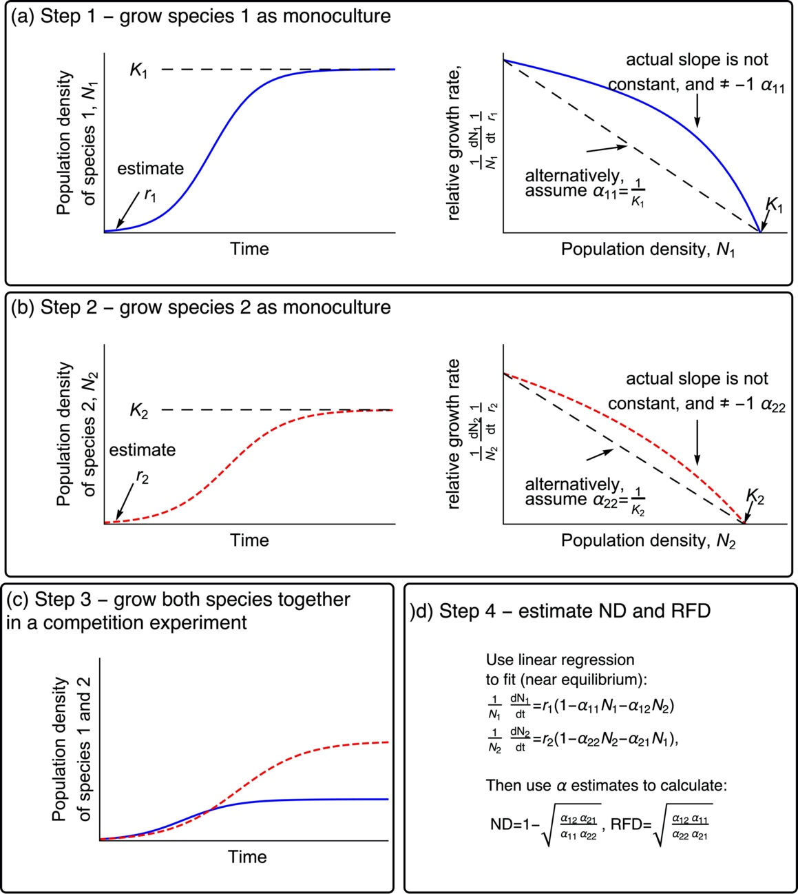

Figure 1. Conceptual plots illustrating how to use the Lotka-Volterra model for continuous reproduction to estimate ND and RFD for use in Chesson’s inequality (Equation 1). In panels a and b, the left-hand plots show the time course of the experiment and the right-hand plots show the relative growth rate as a function of population density – the slope of this relationship is equal to the intraspecific competition coefficient (sign reversed).

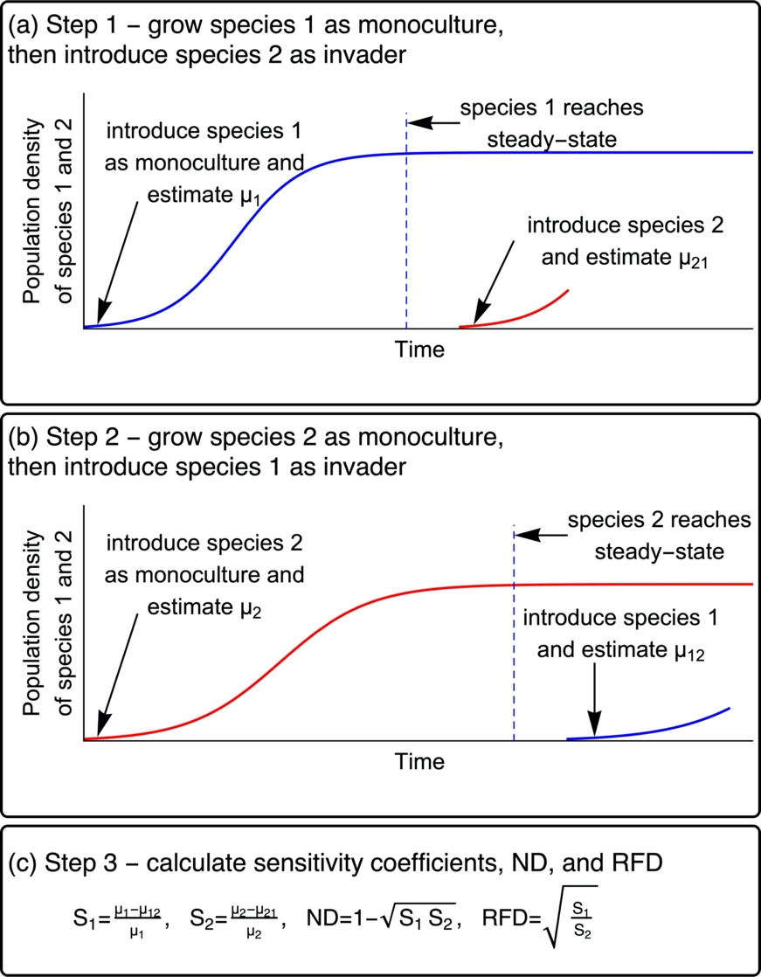

Figure 2. Conceptual plot depicting how to implement the sensitivity method in an experiment.

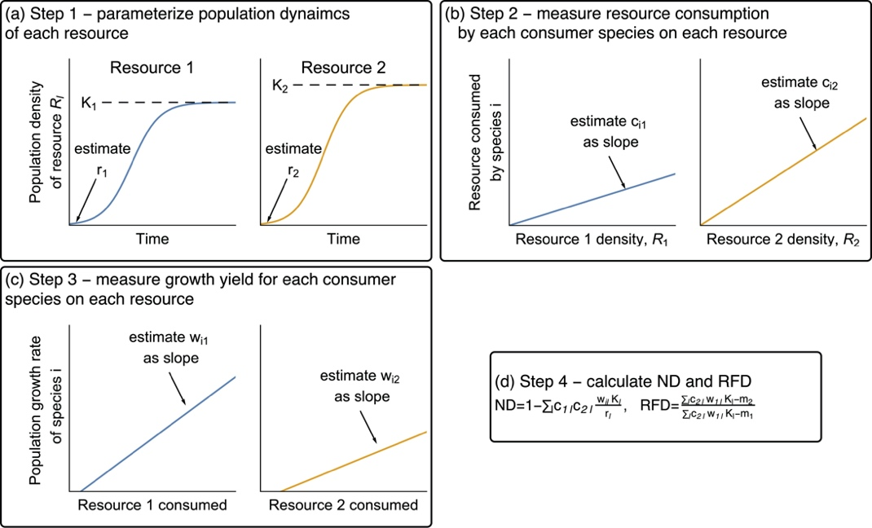

Figure 3. Conceptual plots depicting how the method based on Mac Arthur’s CRM could be implemented.

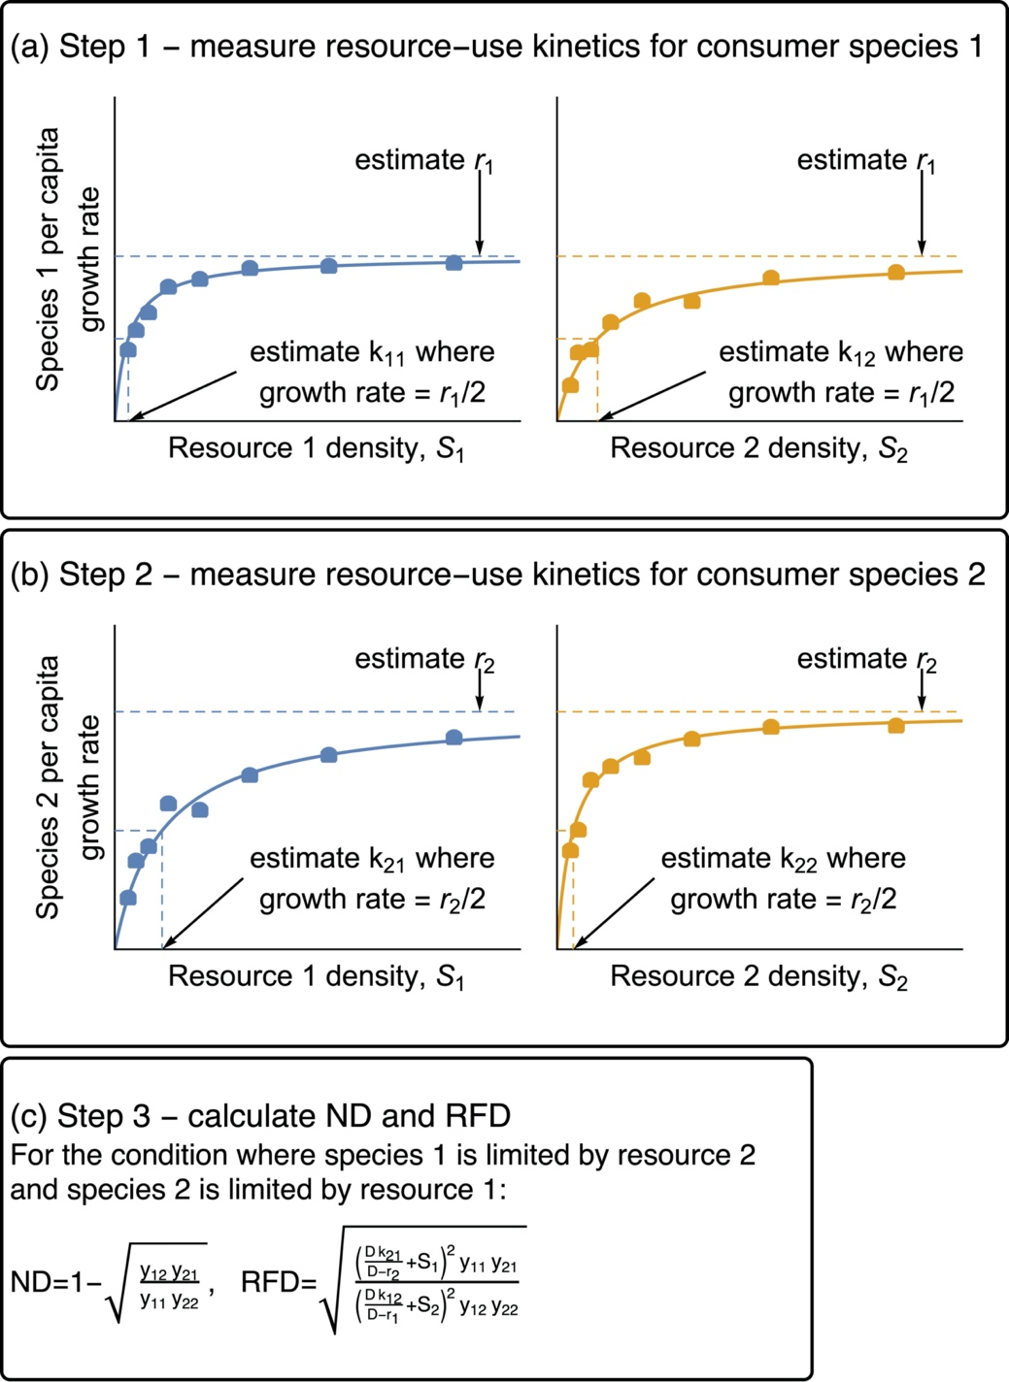

Figure 4. Conceptual plot depicting how to use the method based on Tilman’s consumer resource model. Panels a and b show the experiments needed to parameterize the maximum growth rates and Monod half-saturation constants for growth on each resource, separately for each species. The yield of each species on reach resource (*yii*) can be estimated by measuring the amount of resource consumed by a known number of individuals.

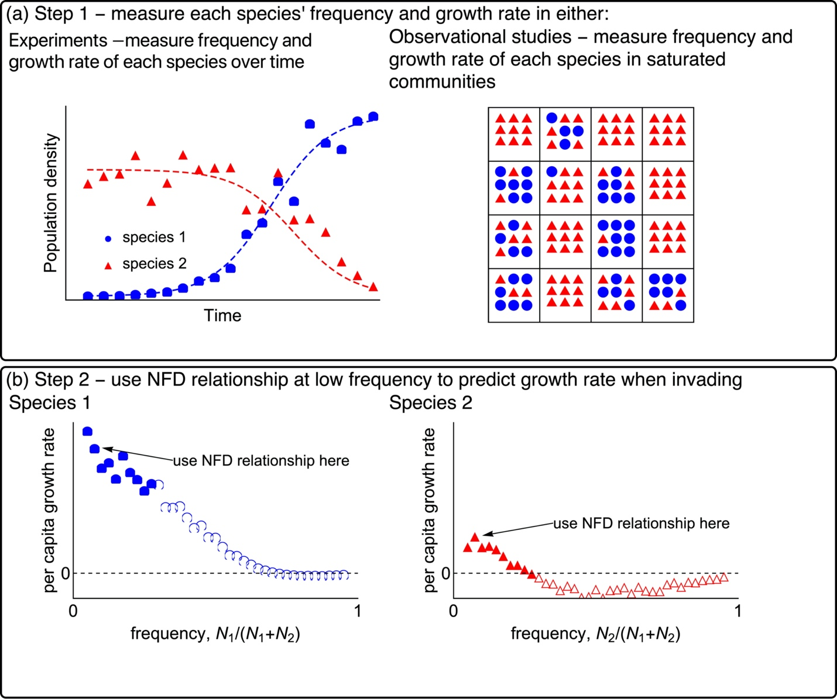

Figure 5. Conceptual diagram depicting how the NFD method could be implemented, either through an experiment or using observational data from different communities. Panel a shows two options for obtaining pairs of each species’ frequency and its growth rate in a saturated community. The first option is to track population densities over time in one or more competition experiments. The second option is to obtain pairs of frequency and growth rate from different communities or habitat patches in a natural ecosystem. Panel b depicts how the data from either experiments or observational studies would be used to estimate the growth rate when frequency approaches zero.

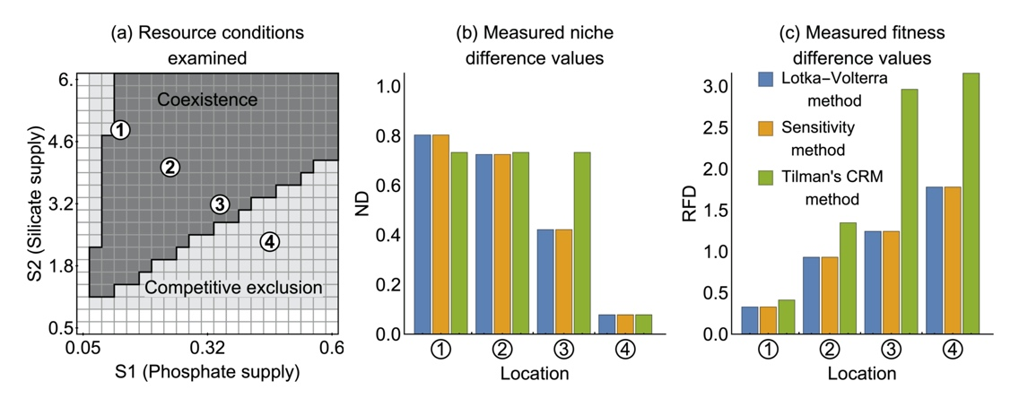

Figure 6. Comparison of four methods for predicting coexistence and estimating ND and RFD. The methods were compared using simulations based on Tilman’s parameterized CRM (Supplementary Material Appendix A). Panel a shows predictions for coexistence based on numerical simulation. White shading means that at least one species does not grow under that combination of resource supply concentrations, light gray shading indicates that the method predicts that the species will not coexist, and dark shading indicates that the model predicts coexistence. The estimated of ND and RFD at points 1-4 in panel a are displayed in panels b and c. The raw RFD values from the sensitivity method were converted to the same ordering as used in the other methods (species *i* in the denominator rather than the species with the greater sensitivity). Because the NFD method cannot be used to produce values of ND and RFD that are comparable with the other four methods, only the predictions regarding coexistence are plotted.